INDEX

Module-2: Introduction to AI and ML
Definition of AI: AI refers to the ability of a digital computer to perform tasks commonly associated with intelligent beings.
Key points:
- Reasoning: AI can reason, discover meaning and generalize.
- Learning: They learn from past mistakes.
- Complex tasks: Can carry out complex tasks like math theorem proofs and playing chess.
Relation Between AI, ML and Deep Learning:
Deep Learning is a subset or subdivision of ML and ML is subset of AI.

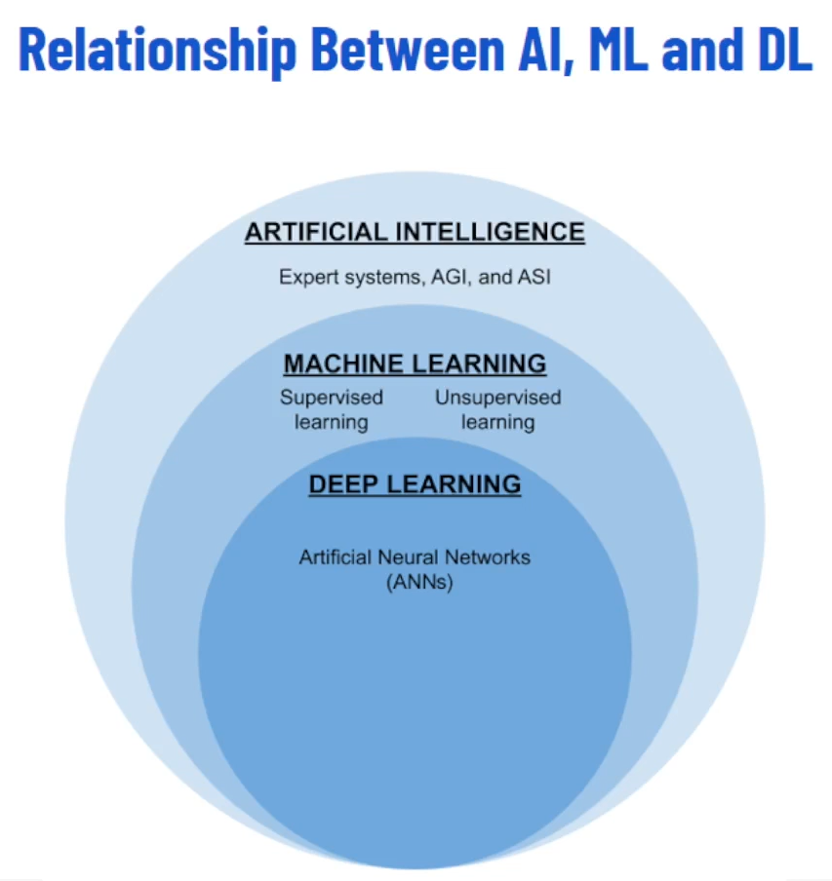

Different types of AI:
- Narrow AI: Focused expertise in specific tasks. For example, chess playing and face recognition.
- General AI: Hypothetical intelligence matching or exceeding human capabilities in all aspects, it called superintelligence.

Definition of ML:
Machine Learning employs data and algorithm to mimic human learning and enhance accuracy over time. Inspired by how humans learn from experience.
Key points:
- Data is the key: Just like we learn from experience. Machines learn from data.
- Data can be anything: Numbers, text, images, videos etc.
- The more data, the better: The more data an ML algorithm has, the better it learns and improves.
- Training the machine: We feed the data to the ML algorithm, like teaching a student.
- The algorithm analyzes the data: It identifies patterns and relationships within the data.
- Making predictions: Based on its learning, the algorithm can predict future outcomes or make decisions.
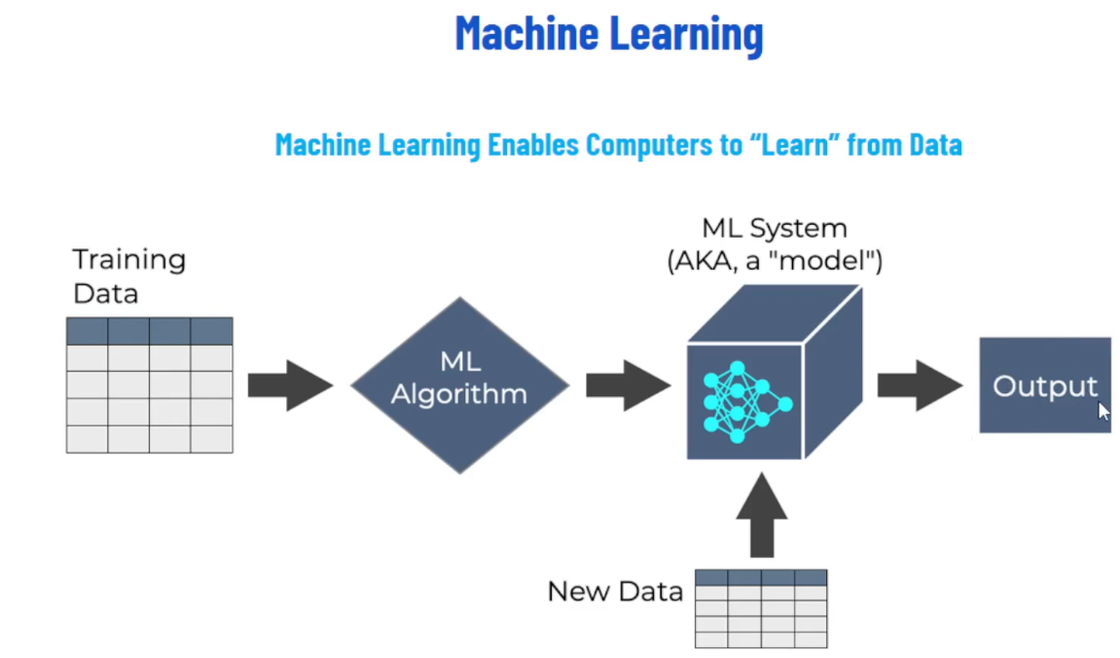

Different types of ML:
- Supervised Learning: Algorithm learn patterns from labeled data to make predictions or decisions. Example: spam filtering and weather predictions.
- Unsupervised Learning: Algorithms that analyze and draw interferences from datasets without labeled responses, like exploring a playground on your own. Example: Grouping customers based on their shopping habits, identifying fraud transactions in credit card data and recommending movies based on your past viewing history.
- Reinforcement learning: AI agents learn through trial and error to maximize rewards in a given environment. For example, a child learning to walk. They take first step (action), wobble (negative feedback), adjusts their balance (learning), and try again (exploration). Eventually they walk successfully (positive feedback)
Unlike supervised learning with labeled data and unsupervised learning with unlabeled data, Reinforcement learning interacts with its environment and learns through a system of rewards and penalties. Like self-driving cars, moving robots.

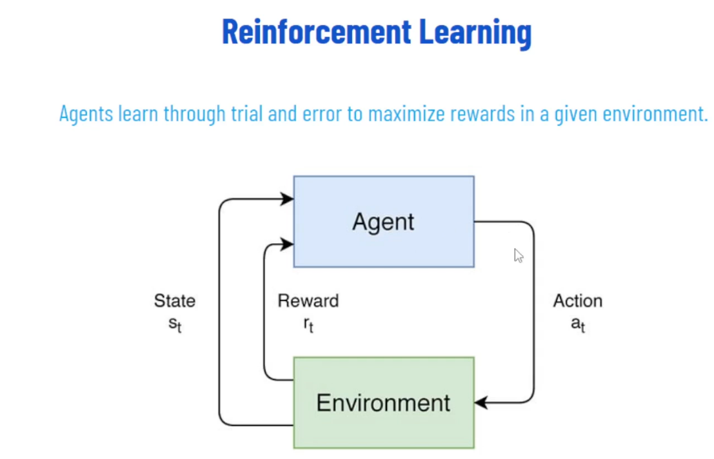

Module-3: Data Fundamentals
Role of Data in AI & ML:
- Foundation: Data is the bedrock of AI and ML systems.
- Fuel: High-quality data fuels accurate model training and predictions.
- Decision-Making: Data-driven decision lead to better outcomes.
Aspect | Importance
Quality | Clean and relevant data ensures robust model.
Quantity | Sufficient data prevents overfitting and improves generalization.
Diversity | Diverse data captures real-world variations and avoid bias.
Timeliness | Fresh data adapts models to changing environments.

Time Value of Data:
- Time value of data refers to the notion that the relevance and usefulness of data diminish over time.
- In many applications, such as financial trading or weather forecasting, recent data holds more value than older data.
- Timeliness of data is crucial for making informed decisions and predictions, especially in dynamic environments.
- Delayed or outdated data may lead to inaccurate analyses or decisions, potentially resulting in missed opportunities or suboptimal outcomes.
- Real-time data processing and analysis techniques are employed to leverage the time value of data.
- Proper data management strategies, including data retention policies and data streaming technologies, help organizations maximize the value of their data over time.

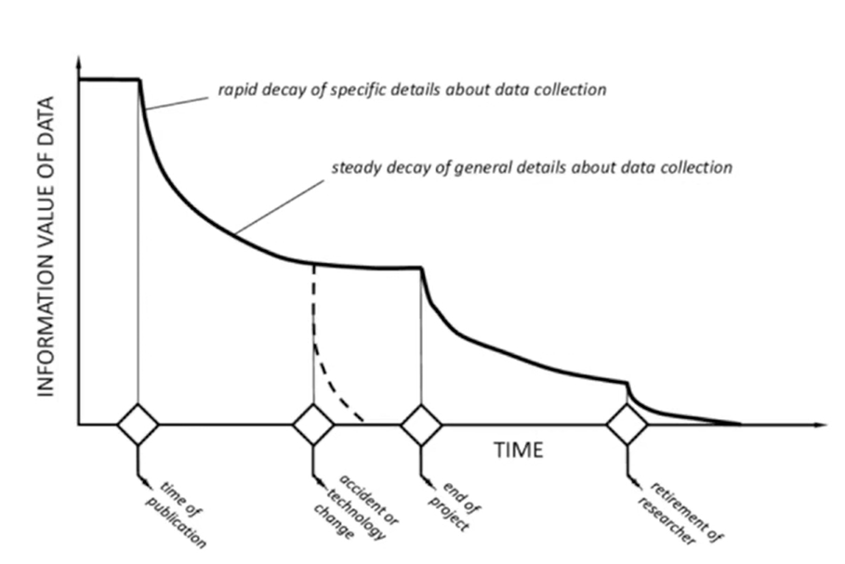

Challenges of Data Management:
- Data Quantity: Having enough data is crucial, but managing massive datasets can be challenging.
- Data Quality: Inaccurate or incomplete data can lead to biased and unreliable AI models.
- Data Security: Protecting sensitive data and ensuring responsible AI development is essential.
Considerations:
- Data Collection: Ethical data collection practices and user privacy must be prioritized.
- Data Cleaning: Ensuring data accuracy and completeness is crucial for reliable AI models.
- Data Governance: Establishing clear guidelines for data ownership, usage, and security is essential.
Types of Data:
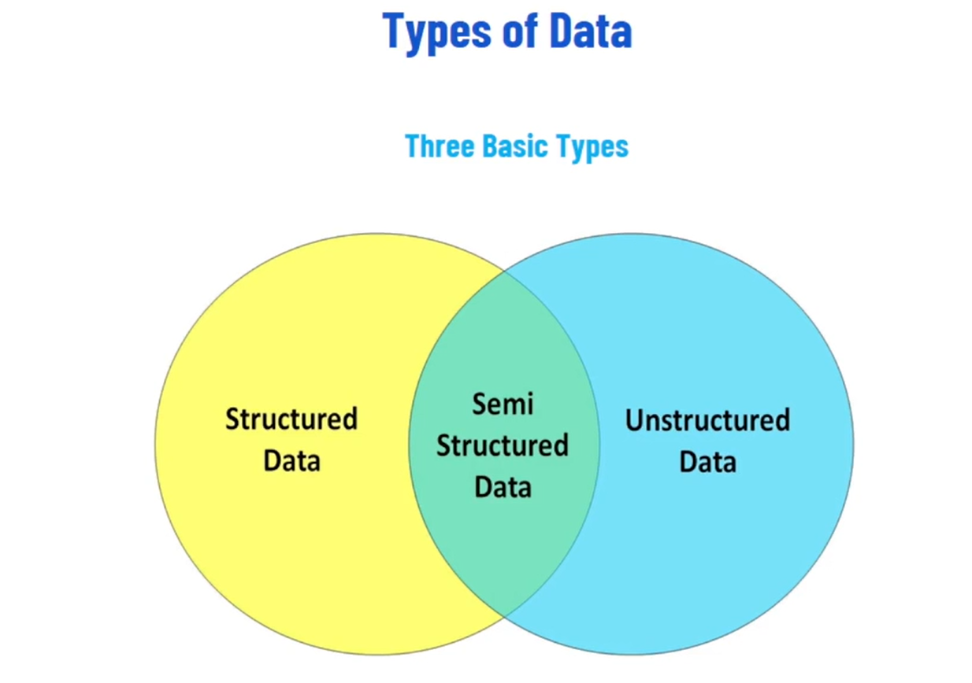

Structured Data:
Data that follows a strict format and is organized into tables with clearly defined relationships.
Examples:
- Relational databases.
- Spreadsheets.
- CSV files.

Characteristics:
Easy to query, analyze, and process using traditional Database Management Systems.
Unstructured Data:
Data that lacks a predefined data model or structure, making it challenging to organize and analyze.
Examples:
- Text documents
- Images
- Audio files and video files
Characteristics:
Contains rich information but requires advanced techniques as natural language processing (NLP) and computer vision for analysis.
Semi-Structured Data:
Data that does not conform to a rigid structure but contains some organizational properties.
Examples:
- XML files.
- JSON files.
- NoSQL databases.

Characteristics:
Offers flexibility in data representation, allowing for a combination of structured and unstructured data elements.
Importance of Structured Data:
- Clear and Consistent: It is well-organized and follows a defined format. This clarity allows AI to easily understand the data points and their relationships, enabling them to learn and make predictions with great accuracy.
- Efficient Processing: The structured nature of data facilitates faster processing by AI algorithms.
- Reliable Training: High-quality structured data is vital for training AI algorithms effectively.
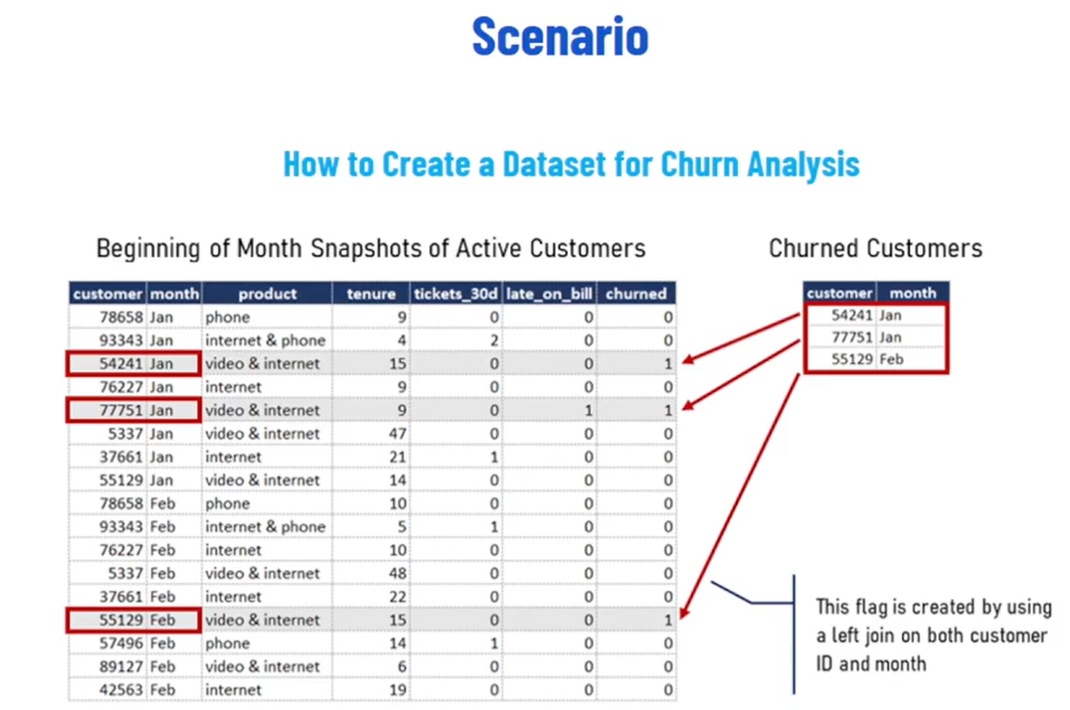

Churn Analysis:
Churn means when a customer leaves (cancels service, stops using product, etc.). Companies want to predict which customers are likely to churn so they can take action. We’re building a dataset where each row is a customer at the start of the month, with details about their activity. By joining with a list of customers who actually left, we add a "churned" label (1 or 0). This labeled data is then used for training ML models.
Challenges of Unstructured Data:
- Complexity: Unstructured data presents challenges in terms of organization, analysis, and interpretation due to its varied formats and content.
- Scalability: Managing and processing large volumes of unstructured data can strain computational resources and storage systems.
- Data Privacy and Security: Unstructured data may contain sensitive information, requiring robust security measures to protect privacy.
Opportunities of Unstructured Data:
- Rich Insights: Unstructured data holds valuable insights and patterns that can inform business decisions and drive innovation.
- Advance Analytics: Techniques such as text mining, sentiment analysis, and image recognition enable the extraction of meaningful insights from the unstructured data.
- Competitive Advantage: Effectively harnessing unstructured data can provide organizations with a competitive edge by uncovering hidden opportunities and trends.
Data Collection (First Step for Analytics):
Data collection involves gathering raw data from various sources, while preprocessing techniques involve cleaning, transforming, and preparing data for analysis.
Importance of Data Collection:
Effective data collection and preprocessing are critical for ensuring the quality and reliability of Data Analysis and Machine Learning models.
Challenges of Data Collection:
- Inaccurate
- Missing
- Imbalanced and biased data
Different Sources of Data:
Various methods can be used to collect data, depending on your needs and resources. Here are some common approaches:
- Internal Data Sources: Leverage existing data within the organization, such as customer databases, transaction records or sensor data.
- Public Datasets: Numerous publicly available datasets can be a valuable resource for various domains but be mindful of licensing and usage restrictions.
- Web Scraping: Extract data from websites using automated tools but ensure compliance with website terms of service and avoid copyright violation.
- Surveys and Questionnaires: Collect data directly from users through surveys or questionnaires to gather specific information.
- Application Programming Interfaces (APIs): Access data from external sources through APIs provided by other organizations but requires proper authentication and authorization.
Exploratory Data Analysis (EDA):
Exploratory Data Analysis or EDA is an approach to analyzing datasets to summarize their main characteristics, often using visual methods.
- Purpose: To gain insights into the data, identify patterns, detect anomalies, and formulate hypothesis for further investigation.
- Importance: EDA helps researchers and analysts understand the structure, relationships, and underlying trends in the data before applying more complex statistical techniques or building predictive models.
Common Techniques for EDA:
Here are few of them but keep on exploring:
- Summary Statistics: Calculate basic statistics like mean, standard deviation, and frequency distributions to get a sense of central tendency and spread within the data.
- Visualization: Create charts and graphs like histograms, scatter plots, boxplots, and heatmaps to visualize data distributions, identify outliers, and explore relationships between features.
- Data profiling: Analyze the characteristics of different variables in the data types, missing value rates, and unique value counts.
- Correlation Analysis: Calculate correlation coefficients to measure the strength and direction of relationships between numerical features.
Data Preprocessing:
- Enhancing Raw Data: Real-world data is often incomplete, inconsistent, and noisy. Preprocessing ensures data suitability for ML algorithms.
- Handling Missing Values: Imputation techniques such as mean, median, or mode replacement.
- Outlier Detection & Removal: Identifying and removing data points that deviate significantly from the rest of the dataset.
- Deduplication: Removing duplicate records to ensure data integrity.
- Data Formatting: Converting data into a consistent format.
Dealing with Outliers:
Outliers are data points that fall significantly outside the expected range. Here are some approaches to handling outliers:
- Investigate the Cause: Outliers can sometimes indicate errors or unexpected events. Investigate the cause before deciding on a correction method.
- Capping: Set a threshold and replace outliers with the threshold value.
- Removal: In some cases, removing outliers might be appropriate, especially if they are confirmed errors or irrelevant to your analysis.
Data Transformation:
Data transformation involves modifying the format or scaling the values of your data to improve its usability for AI and ML models. Here are some common transformations:
- Normalization: Scaling numerical data to a specific range (e.g. 0 to 1) to ensure all features have a similar influence on the model.
- Standardization: Scaling numerical data to have a mean of 0 and a standard deviation of 1, often used for algorithms sensitive to feature scales.
- Encoding Categorical Features: Converting categorical data (e.g. text labels) into numerical values that algorithms can understand (e.g. one-hot encoding).
Data Feature Engineering:
It involves creating a new feature from existing data or selecting the most relevant features for your model. This step can significantly impact model performance. Here are some considerations:
- Domain Knowledge: Leverage your understanding of the problem domain to identify potential features from the data.
- Feature Selection: Choose features that are most informative and contribute significantly to the model’s ability to learn.
- Feature Creation: Derive new features by combining existing ones or applying mathematical transformations.
Addressing Data Imbalance:
Data imbalance occurs when a dataset has a significant difference in the number of data points belonging to different classes. This can lead to problems for AI and ML models, causing them to:
- Be biased towards the majority class and perform poorly on the minority class
- Not generalize well to unseen data with a more balanced class distribution.
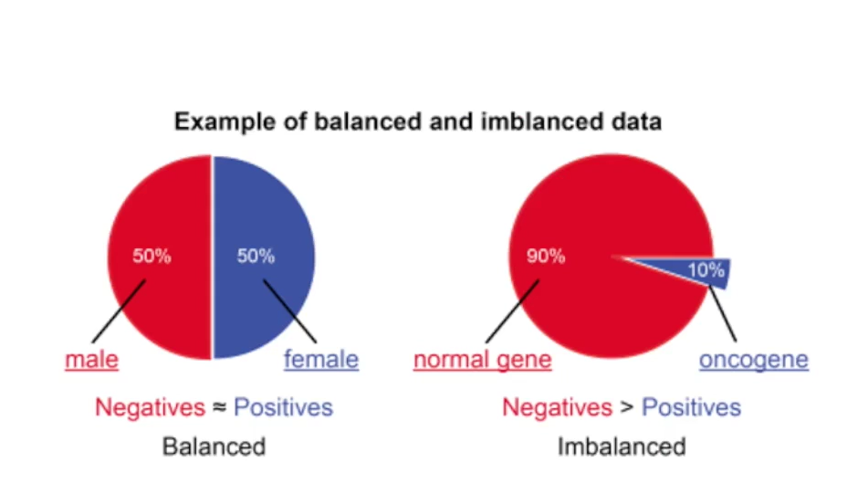

Techniques to Address Data Imbalance:
- Under-sampling: Reduce the number of data points in the majority class to match the size of the minority class.
- Over-sampling: Replicate data points from the minority class to increase its representation in the dataset.
Data Visualization for Effective Preprocessing:
It is a powerful tool that can aid in data preprocessing by:
- Identify missing values and outliers.
- Understand data distribution.
- Explore relationships between features.
